LAB SESSION 11
Programming Exercise:
Question 1: Create a Book class that has title, author, and a Date object for the publication date. Implement a method to display the book details.

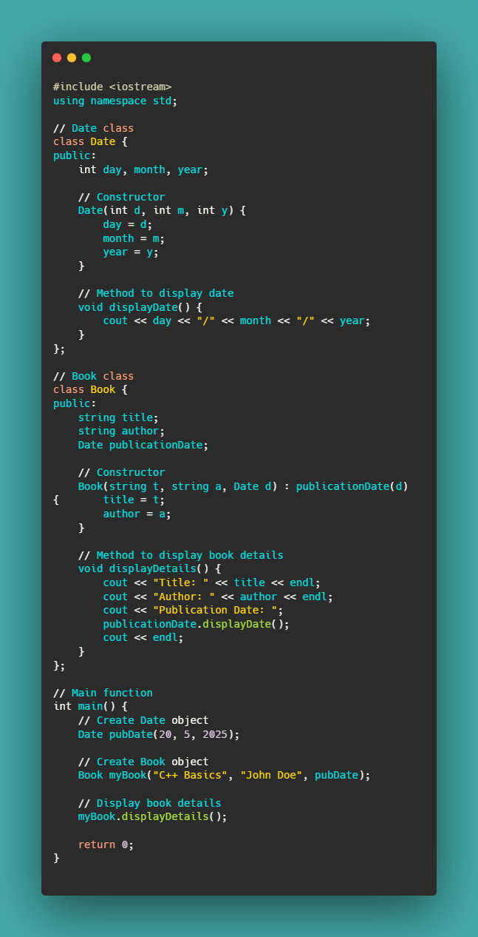
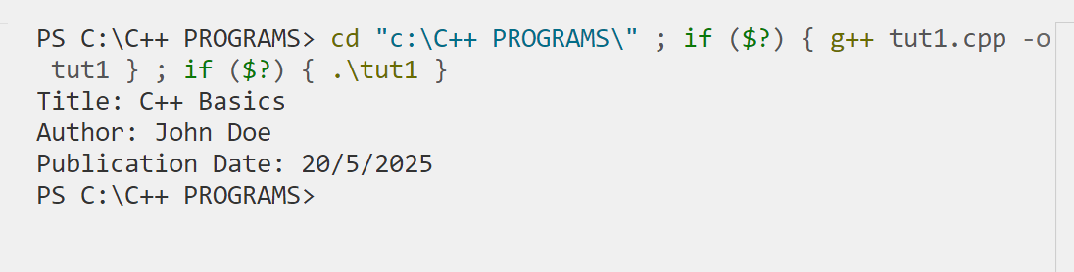

Question 2: Create a Library class that can hold multiple Book objects. Implement methods to add books and display all books in the library.

